

**Final Draft-Report**

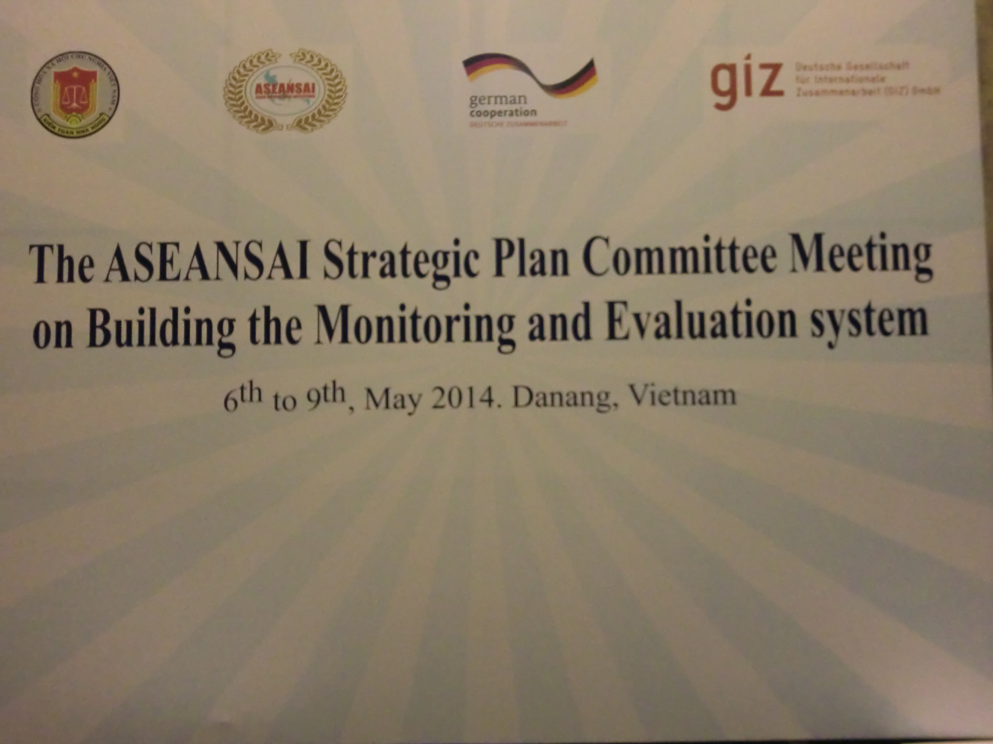

**- Name of Committee: ASEANSAI Strategic Plan Committee**

**- Committee Chair and organizing SAI: The State Audit Office of Vietnam**

**- Member participating SAIs: Brunei, Cambodia, Indonesia, Malaysia, Philippines and Vietnam**

**- Facilitator: Nikolas Beckmann (GIZ)**

**- Reporting Date: 31.05.2014**

**- Status: Final Draft**Content

**1. Objectives of the workshop 3**

**2. Process and Agenda of the Workshop 3**

**3**. **Outputs and Agreements based on the Review of the ASEANSAI Strategic Planning Framework** 3

3.1 Definition of a result framework 3

3.2 Identification of gaps in the committee work plans 3

**4.** **Tools and Procedures proposed for the ASEANSAI Monitoring System** 3

4.1 Tools and Agreements on Process Monitoring 3

4.1.1 Participant evaluation sheet 3

4.1.2 Event assessment sheet 3

4.1.3 Periodic assessment sheet on activities of committees 3

4.2 Tools and agreement on Result Monitoring 3

4.3 Other monitoring tools 3

**5**. **Way forward** 3

5.1 Finalization of the workshop report 3

5.2 Approval process for the monitoring system and amendment of work plans 3

5.3 Open issues related to the planning and monitoring system 3

**Attachments:**

Annex 1 Welcome speech by Prof. Dr. Doan Xian Tien, Deputy Auditor General of the State Audit Office of Vietnam

Annex 2 Agenda of the ASEANSAI Strategic Plan Committee Meeting on Building the Monitoring and Evaluation System

Annex 3 List of participants

Annex 4 Result framework for planning and monitoring strategic objectives of ASEANSAI

Annex 5.1 Participants evaluation template

Annex 5.2 Event reporting template

Annex 5.3 Tool periodic monitoring

Annex 5.4 Result monitoring matrix (ASEANSAI results and key performance indicators)

## Objectives of the workshop

The ASEANSAI Strategic Plan Committee (SPC) monitoring and evaluation workshop was held in Da Nang, Vietnam from May 6th to 9th 2014. The workshop was hosted by the SAI Vietnam as Chair of SPC and served as a discussion forum for all member of the SPC, as well as the SAI Brunei and the SAI Cambodia, which are currently serving as the Executive Committee of ASEANSAI (see full list of participants in annex 3). As Prof. Tien, the Deputy Auditor General of the State Audit Office of Vietnam (SAV), pointed out in his welcome speech to the SPC representatives, ASEANSAI has gained valuable experiences during the time of 2011 – 2013. He emphasized the importance of the **workshop in Da Nang** for the **discussion and development of the monitoring and evaluation system for ASEANSAI**’s Strategic goals, because this system is an important precondition to evaluate the implementation of ASEANSAI Strategic Plan for 2014 – 2017 (see welcome speech in annex 1).

To achieve this overall objective of the workshop, the agenda (see annex 2) addressed four major areas:

1. Laying the foundation for a functioning monitoring system by identifying concrete outcomes that will link the strategic plan and the work plans; agreeing on indicators to measure these outcomes and identify milestones that constitute important intermediary outputs to be achieved during the implementation period of the ASEANSAI strategic plan.
2. Developing the baseline information on the indicators and agreeing on the way to collect the data, thus establishing the results framework that will be the basis to measure the progress towards the outcomes and the strategic objectives.
3. Discussing on proposed tools for data collection and reporting templates on the implementation process and for the results monitoring, and agreeing on the monitoring processes and responsibilities.
4. Agreeing on the way forward after the meeting to follow up on the agreements and ensure that the agreements reached during the workshop are actually followed up and implemented.

Monitoring is the basis for a results-oriented management of ASEANSAI activities. The monitoring system must ultimately inform the ASEANSAI committees, and its members if the activities they are implementing are actually contributing to the strategic goals of ASEANSAI. The processes and instruments that constitute the ASEANSAI monitoring system discussed in this initial workshop will be elaborated and tested in 2014, and shall subsequently become part of the management processes, providing information that allows informed management decisions for the successful implementation of the ASEANSAI strategic plan.

## Process and Agenda of the Workshop

Following the welcome from Prof. Tien and the opening remarks from Mr. Giang as representatives of SAI Vietnam, Chairman of the SPC, the SPC members discussed the following topics in the order indicated below.

* Review the SMARTness of the ASEANSAI strategic objectives to define concrete and measurable outcomes;
* Identify result - related indicators and data collection methods for these indicators;
* Develop implementation milestones (major outputs) for the ASEANSAI strategic objectives and the identified concrete outcomes;
* Linking milestones with activity planning and identify existing gaps in the work plans;
* Discuss proposed instruments for data collection and reporting;
* Agree on the monitoring plan to organize the activities for data collection, data collation and reporting;
* Discuss the way forward to conduct the required amendment of the work plans and to communicate the implications to the Executive Committee and the committee chairs and ASEANSAI member countries not present at the Da Nang meeting.

Inputs from the facilitator-on the methodology of result - based management and monitoring and on the proposed draft instruments - served as an introduction for the participants’ deliberations on the various topics. Intensive discussions in group works allowed a reflection on the methodology and an application of the presented concepts and tools for the ASEANSAI strategic plan. The results of the group works were always presented back to the plenary; this ensured a common understanding of all participants on the discussed topics on the one hand, and allowed a documentation of the agreements reached in the plenary discussion on the other hand.

## Outputs and Agreements based on the Review of the ASEANSAI Strategic Planning Framework

### 3.1 Definition of a result framework

The starting point of the SPC’s discussion on the ASEANSAI monitoring system was the **definition of concrete and thus measurable outcomes for the** 6 strategic objectives under the 4 strategic goals of the **ASEANSAI strategic plan**. While the strategic objectives of the strategic plan provide the overall orientation for the work of the ASEANSAI committees, concrete outcomes (defined as “expected changes of the situation or the behaviour of stakeholders due to the intervention of ASEANSAI”) are needed for two purposes:

Firstly, these outcomes allow committees to ensure that the work plans of the committees actually foresee the measures that are required to achieve the defined outcomes.

Secondly, these concrete outcomes can be translated into “result indicators”, thus enabling ASEANSAI to establish a monitoring system that goes beyond the implementation of activities and also checks, whether the intentions of the ASEANSAI endeavours according to the strategic plan are met.

It must be emphasized that the defined **concrete outcomes do not change the strategic plan approved by the ASEANSAI assembly but should be seen as amendments in order to facilitate monitoring** as well as a better understanding of the activities that have to be conducted by the various committees with regard to the objectives of the strategic plan.

Based on the shared understanding of the concrete outcomes related to the strategic goals and objectives of ASEANSAI, the working groups continued (in several stages) to **define** the following **elements of the result framework** for the various strategic objectives:

* Result indicators[1];
* The sources of verification that will provide the data to measure the result indicator;
* The baseline value;
* The target value / the scope of changes that shall be achieved by the end of the project phase (in 2017).

Annex 4 is summarizing the results of the intensive discussion on the framework for planning and monitoring related to the strategic objectives of ASEANSAI in a comprehensive format.

### 3.2 Identification of gaps in the committee work plans

To identify the scope of the required amendments, the groups continued the discussion on the result framework by defining concrete milestones (major outputs that have to be achieved in order to reach the envisaged result) and identifying major activities that are required to produce these milestones. These milestones and major fields of activities are also documented in the result framework in annex 4.

It was observed in the review process that **some** of the **objectives in the ASEANSAI strategic plan** (and accordingly also some of the concrete outcomes identified for these strategic objectives) were **not addressed by the work plans of the ASEANSAI committees**. A strategic objective that is not addressed by any activities or outputs to create the anticipated change is of course not meaningful.[2] To identify the areas in which amendments in the existing working plans are required, the SPC reviewed the involvement of the ASEANSAI committees in the implementation of activities related to the strategic objectives. The following table indicates in which areas **amendments of the committees’ work plans** are required.

|  |  |  |  |
| --- | --- | --- | --- |
| **Strategic Objective (SO)** | **Involved Committees** | **SO Covered by Work Plan (yes / partly / no)** | **Responsibility for the elaboration / amendment of work plan (lead in bolt)** |
| SO1 - To ensure the active role of the ASEANSAI in the ASEAN Community | Executive Committee  Admin.Office  Secretariat | No | **Brunei**  Indonesia |
| SO 2 - To promote the enhancement of the independence of the member SAIs | Executive Committee  KSC | Partly | **Malaysia**  Brunei |
| SO 3.1 - To improve organizational capacity building of member SAIs | KSC  TC  Executive Committee | Partly | Philippines  **Malaysia** |
| SO 3.2 - To improve audit capacity building of member SAIs | KSC  TC  Executive Committee | Partly | Philippines  **Malaysia** |
| SO 4.1 - To develop institutional relations with ASOSAI and INTOSAI | Executive Committee  Admin. Office  Secretariat | No | Brunei  **Indonesia** |
| So 4.2 - To enhance partnership with donors to increase the effectiveness of foreign funded projects implemented within the ASEAN Region | Executive Committee  Admin. Office  Secretariat | No | Brunei  **Indonesia** |

Table 1 – Adaptation of work plans – need and responsibility

## Tools and Procedures proposed for the ASEANSAI Monitoring System

An outcome-oriented **monitoring system** **must** consist of several tools to **capture** all **the stages of the intervention logic** that is depicted in the graphic below.

The monitoring tools must answer on the one hand the question, **whether the stakeholders** involved in ASEANSAI **have done what was agreed** in the work plan (provide inputs, conduct activities and produce outputs). On the other hand, the committees responsible for the management of ASEANSAI must of course know, **whether the project has achieved the desired outcomes**.

Although it is the results that matter, we need to collect information on inputs, activities and outputs for two reasons.

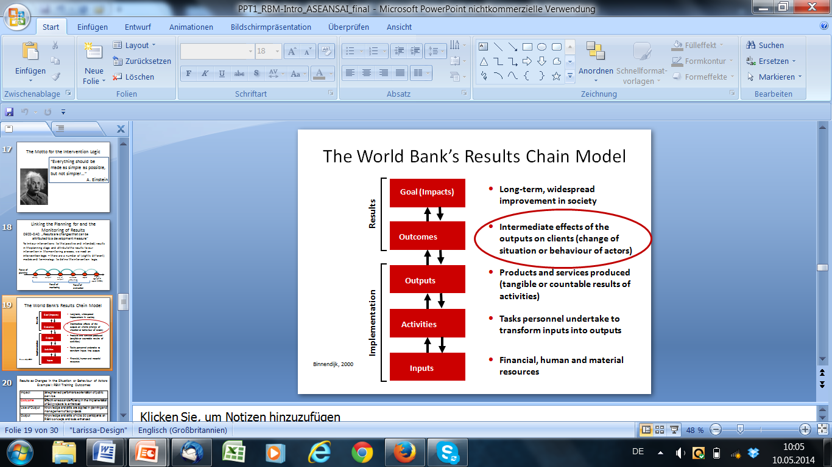

Firstly, data collection on the outcome level is usually time consuming and costly. The information on outcomes is therefore usually collected only once a year. For project management, this is a rather long period; management therefore relies on the information on the implementation status, which should be collected more often to enable the management to react to unforeseen developments and effectively steer the implementation of the project.

Secondly, management needs additional information, if the monitoring shows that we don’t achieve the expected outcomes. We need to know, whether it is due to shortcomings in the implementation (lack of inputs, activities not conducted, outputs not produced or produced in a bad quality), then project management needs to react. Or whether results are not achieved due to flaws in the intervention logic (outcomes do not occur as anticipated, although the implementation of the project was fully in accordance with the project plan), then the strategy needs to be revised.

To collect the information on the different stages of the intervention logic, the project managers need several layers of tools to provide the respective information. The combination of these tools - for **process monitoring,** capturing everything that is part and parcel of the implementation process (input, activities, outputs), **and for results monitoring,** looking at the outcomes and goals – as well as the processes regulating how the tools are used to collect the information that is relevant for project management **constitute the monitoring system**. The graphic below shows these layers of the monitoring system.

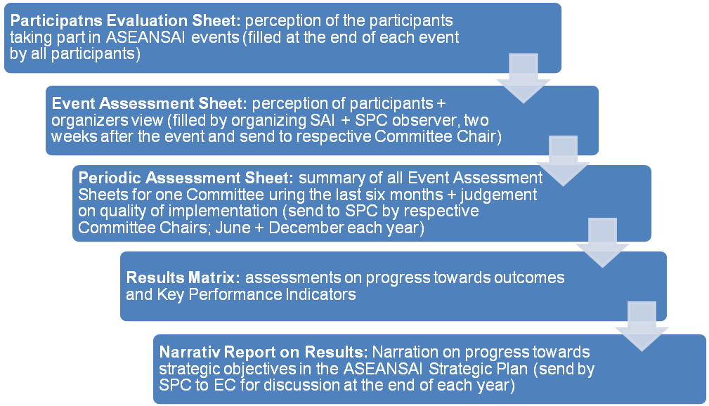

In the following chapters the indicated tools, which have been discussed and adopted by the SPC, will be briefly described.

### 4.1 Tools and Agreements on Process Monitoring

The **events and activities conducted by ASEANSAI constitute the basis for all the results** that shall be achieved. Therefore the monitoring system relies on a feed-back mechanism providing information on these “foundation stones” for the intervention logic of ASEANSAI. Two monitoring tools shall be combined to provide management (the committee chairs and the SPC) with information on the three quality criteria (provision of input, timeliness, deliverables) that are relevant to assess these activities.

### 4.1.1 Participant evaluation sheet

Firstly, the **perception of the participants is relevant to assess the quality** of the organization and the inputs of an event, and also to learn about the participants’ perception how appropriate the content of the event was to build their knowledge and skills, and how they can apply the content in their place of work. The events differ of course with regard to the specific content and objectives, and therefore the evaluation template to monitor the events must always be adapted to the specific content of the event. A generic core for such an evaluation sheet can, however, help the organizers of ASEANSAI activities in elaborating such an evaluation sheet. Moreover, it can also ensure standardization in the use of evaluation scales as well as ensure that some key questions are included in all event evaluation formats.

Comments and recommendations on the design of the questionnaire used for the evaluation of the ASEANSAI SPC meeting in Da Nang were discussed during the workshop. These recommendations were incorporated in the version of the questionnaire that is attached to this report as annex 5.1. Questions that were specifically on the content of the Da Nang workshop were removed so that the document in the annex can serve as a basis for the design of participants´ evaluation questionnaires for future events.

### 4.1.2 Event assessment sheet

The evaluation by participants constitutes one input for the next layer of monitoring, which is **the summarizing assessment of the event**. This reporting template on activities will be filled **by the organizing SAI, together with an observer from the SPC**. It will summarize the assessment from participants and also document (from the organizers point of view) what has worked well and what needs to be considered when organizing similar events in the future.

The focus of the assessment is on the deliverables of the event. The timeliness of the implementation and organization of the event are the other categories that will be assessed. The template for this questionnaire was presented at the workshop and tested by SPC members on their experiences organizing past events. Comments were taken up and incorporated in the template attached as annex 5.2.

It is important to highlight, that the design of these assessment templates benefit a lot from the experiences gained when the tools are applied in practice. Therefore the templates shown in the annex must in general not yet be regarded as final versions. It was accordingly agreed that the event assessment form for the SPC monitoring meeting in Da Nang (based on participants’ evaluation forms and organizers perception) will be finalized by the Vietnamese colleagues and will be distributed to all SPC members. The feed-back based on the review will also serve as an input to finalize the event assessment template.

Further comments based on practical experience are also highly welcome in the coming months; it is proposed that GIZ will serve as a facilitator, collecting the comments, incorporating them in the tools and getting approval from the SPC for the proposed changes.

### 4.1.3 Periodic assessment sheet on activities of committees

The final layer of the process monitoring is a **periodic assessment of the progress made by the committees in the implementation of their respective work plan**. According to the **ASEANSAI rules and procedures** such an assessment has to be conducted bi-annually to provide a basis for the report to the Executive Committee**.** The template summarizes the information from the event assessments in the six-months reporting period and judges the quality of the implementation. Finally, it also evaluates, whether the progress towards the outcomes and the strategic objectives is meeting the expectations according to plan.

Again, comments and recommendations on the design of the periodic assessment form were collected and incorporated in the version attached to the report as annex 5.3. The instrument will be tested for the first time to do the bi-annual assessment by the end of June 2014. Again, the experiences from this application in practice will be collected by the SPC in order to incorporate eventually necessary changes in the template, thus finalizing the tool.

The structure of the work plan for the Secretariat and the Administrative Officeis different from the other committees actually implementing activities. Accordingly, the monitoring template developed for these committees cannot be applied to assess the performance of these committees. An adapted version of the periodic assessment template that will meet the requirements of the Secretariat and the Administrative Office will have to be elaborated.

### 4.2 Tools and agreements on result monitoring

**Whether ASEANSAI is on track with regard to the envisaged results** of the strategic plan implementation **is the key question** for the management of ASEANSAI. The monitoring system must therefore provide information, whether ASEANSAI is really achieving what it hopes to accomplish on a regular basis. The outcomes have been defined during the workshop and also indicators to measure the progress with regard to these outcomes have been identified and documented in the result framework. Annual milestones, which will serve as benchmarks for the appraisal of the actual progress have been set (at least if sufficient information allowed the SPC members to make a meaningful prediction for an “ambitious, but reasonable” target value). Moreover, the responsibility for the collection of the respective data has been agreed.

These agreements on the indicators to measure the concrete outcomes and the expected development over time (achievement of milestones and / or changes in the indicators) are documented in the result matrix (see annex 5.4. table 1). The agreements with regard to methodologies and responsibilities for data collection and data collation for reporting are documented in the result plan (see annex 5.4. table 2). Similar agreements on milestone targets and data collection responsibilities were also reached for the key performance indicators; these are documented in annex 5.4. Table 3 (key performance indicator matrix) and annex 5.4. Table 4 (key performance indicator monitoring plan).

The periodic process assessment (using the template in annex 5.3) and the assessment of progress with regard to the milestones and outcomes in their respective field of responsibility (documented in the tables in annex 5.4) will be conducted by the head of the respective committees. The SPC will review these reports and clarify open issues with committee heads if required. The **SPC will** then **collate all the information** on the implementation process and on the results **in a** **narrative draft report,** which is sent to all committee chairs and the Executive Committee. The draft report shall serve two purposes. Firstly, the report shall **facilitate the discussion** **between the SPC and the Executive Committee on the performance of ASEANSAI** and - more importantly-**inform management decisions on the way forward**. Secondly, and based on the discussion between the SPC and the EC, a consolidated report that reflects the management decisions of the EC for the coming year will be used to officially inform the SAI’s from member countries and other involved stakeholders on the progress in the previous year and on the way forward in the coming year.

### 4.3 Other monitoring tools

It was agreed by the participants that the expectation of important (internal and external) stakeholders with regard to the overall results of the ASEANSAI would be important information for the management of the ASEANSAI and future strategic planning processes. Also, such a survey could serve as a baseline for a **comparative assessment of the overall satisfaction of the SAI’s leadership** and other stakeholders with the deliverables and results of ASEANSAI at the end of the Strategic Plan. Concept and process for this study have, however, not been discussed in detail during the meeting.

A more in-depths discussion on the way forward is needed. This discussion shall be based on the experiences that Indonesia and Malaysia[3] have with regard to such an assessment of stakeholder expectations on the one hand, and on a brief concept note by GIZ outlining possible scope and processes for the assessment of the overall satisfaction of stakeholders and SAI´s leadership.

## Way forward

### Finalization of the workshop report

By 23.05.2014, the workshop participants will review the present draft report+annexes (prepared and sent by GIZ by 19.5.2014), and send comments to SAI Vietnam.

SAI Vietnam will incorporate comments and send the final report and annexes on behalf of the SPC to the Administrative Office by 30.05.2014. The Administrative Office will forward the final report and annexes to all SAI, the EC and all Committee Chairs without delay (02.06.2014).

The templates attached to the draft report as annexes will be reviewed by the SPC members; eventual comments will be submitted to SPC and GIZ and incorporated into the templates by GIZ in consultation with the SPC. If and when experiences from the application in ASEANSAI suggest that additional changes would improve the quality or applicability of the tools further, then suggestions will also be forwarded to SPC and GIZ.

Moreover, a guideline on the monitoring system - outlining the intention of the various tools and of the system as a whole – as well as on the roles and responsibilities of the various ASEANSAI bodies to execute monitoring tasks and utilize the information generated by monitoring activities will be elaborated. GIZ will submit a draft to the SPC, which will review the guideline and then forward it to all committees.

The ASEANSAI rules and procedures foresee a **report to the Executive Committee on a bi-annual basis**. The **reporting format** to summarize the information from all committees in such an aggregate, bi-annual report[4] for the Executive Committee has not yet been discussed or agreed. The next reporting is due by the end of June 2014; by then also the monitoring tools and formats discussed by the SPC in Da Nang shall be tested in practice, and used to report to the Executive Committee. The experience from the documentation of the monitoring findings in the report to the Executive Committee shall be used also to agree on a standardized reporting format for future reports to the EC.

### Approval process for the monitoring system and amendment of work plans

It was emphasized that the elaborated **monitoring system and the amendments in the work plans need to be approved by the ASEANSAI Executive Committee**.

An in-depth discussion of the appropriate **steps to facilitate this approval and adaptation process** and to create ownership of the ASEANSAI chair came to the following conclusions:

* The SPC will send the workshop report + annexes to EC before 30th of May.
* Communication should not be limited to this report or explanation by e-mail; an explanation and discussion with the Executive Committee is needed to highlight that:

1. the strategic plan was not changed;
2. the introduced results framework with its additional indicators and milestones is in fact focussing on assessing progress on the strategic plan;
3. The amendments of the committee work plans accordingly address strategic objectives that had not been covered by activities.

* Workshop participants will inform their own SAI leadership about the workshop results and will lobby for the necessity of the introduction of a monitoring system and the work plan amendments.
* Member countries not present at the monitoring workshop will also receive information beyond the workshop report; members of the meeting will be available to provide additional information in a bilateral exchange. It was agreed that Malaysia is informing colleagues from Singapore and Thailand; Indonesia will be informing Myanmar and Vietnam will contact the colleagues from Laos.
* **The final approval of the monitoring system and the amendments to the work plans shall be reached in a Senior Officials Meeting with participation of all SAI, the ASEANSAI Chair and Committee Chairs at the end of June 2014.** This meeting will be organized as a “side event” to the focus group discussion on ISSAIs implementation that will be taking place from 18th to 21st of June 2014.
* SAI Malaysia will draft the Agenda and send out the invitations for that meeting in co-operation with the EC; the meeting will be chaired by EC, moderation will be facilitated by the SPC Chair and reporting will be done by the Administrative Office.

### Open issues related to the planning and monitoring system

* To complete the result framework, the baselines and target values for indicator 2 and 3.1 and 3.2 have to be set. This will be based on the self-assessment of ISSAI implementation to be discussed in Malaysia in June 2014.

To assess progress with regard to independence of SAIs, organizational capacity and audit capacity annually a questionnaire needs to be elaborated. The questionnaire must assess whether changes in these areas have taken place, and whether these changes are an outcome of the activities of ASEANSAI. The responsibility to elaborate a draft version of this tool and the process to test and apply the questionnaire has to be agreed in the coming months; it was agreed, however, that the EC (Brunei) would lead the execution of this task with support from Malaysia.

* A follow-up meeting of the SPC, reflecting on the first experiences with the application of the monitoring system and preparing the annual report for the Executive Committee was agreed. The exact date, the venue and the detailed objectives for next meeting of the ASEANSAI SPC shall be agreed at the meeting in Malaysia end of June 2014.
* The technical aspect of establishing the monitoring system was not discussed. The SPC will have to propose a technical solution that would enable all SAI’s to access the monitoring templates, and even more important to store the reports so that they are accessible for all SAI’s. A solution that makes use of the cloud technology (e.g. drop box with access administered by the SPC) seems appropriate; a decision has, however, not yet been taken.

1. The conceptual approach with regard to the strategic objectives 1 (active role of the ASEANSAI in the ASEAN community) and 4.2 (partnership with donors to increase the effectiveness of foreign funded projects implemented within the ASEAN Region) is complex and takes a very long time to develop; therefore the SPC doesn’t expect to achieve results / changes in the situation during this project phase. The indicators in these areas are therefore defined as outputs, which are expected to lead to results in the time period to be covered by the next strategic plan.
2. This flaw in the design of the intervention logic for the strategic plan might have been due to the organization of work plans for the various committees. While some of the strategic objectives need activities to be carried out by several committees (and are, e.g. in the KSC and the TC addressing strategic objective 3.1. and 3.2, in fact also captured in these committee work plans) other strategic objective were obviously forgotten when the committees were developing their work plans.
3. If other countries have also experiences in the assessment of stakeholder perceptions, than their input is of course also highly appreciated.
4. While the mid-year report will be limited on aggregating the information from the committees’ periodic reporting, the end of the year report shall also include the information on the key performance indicators (activities) as well as on the result indicators, respectively the milestones.